Exam Two: Grammar & Sentence Patterns
Name: ________________________ Date: ________________

Test Overview
Multiple Choice: 28 points
- 14 questions at 2 points each
- 20 minutes
Sentence Revision: 18 points
- 6 questions at 3 points each
- 10 minutes
Sentence Patterns -- Label and Diagram: 30 points
- 3 diagrams at 10 points each
- 15 minutes
Coordination and Subordination - Diagram: 24 points
- 4 questions at 6 points each
- 15 minutes
Bonus: Sentence Creation: 10 points
- 5 Questions at 2 points each
- 10 minutes
Section A: Multiple Choice
Question One: Which of the following sentence patterns best describes the sentence below? (2 pts)
Sentence: The old musician played beautifully at the concert.
a. Linking Verb with a Subject Complement (Adjective Phrase)
b. Intransitive Verb
c. Ditransitive Verb with a Direct Object and an Object Complement (Noun Phrase)
d. Copular Be with a Subject Complement (Noun Phrase)
Answer: _____

Question Two: Which of the answers below is serving as an Optional Adverbial in this sentence? (2 pts)
Sentence: During the meeting, the manager presented the quarterly results.
a. "the manager"
b. "During the meeting"
c. "the quarterly results"
d. "presented"
Answer: _____

Question Three: Which of the answers below is serving as a Subject Complement in this sentence? (2 pts)
Sentence: The old house became a beautiful home over time.
a. "The old house"
b. "became"
c. "a beautiful home"
d. "over time"
Answer: _____

Question Four: What type of phrase listed below best describes the Object Complement in this sentence? (2 pts)
Sentence: The board considered the proposal quite innovative.
a. Prepositional Phrase
b. Noun Phrase
c. Adjective Phrase
d. Adverb Phrase
Answer: _____

Question Five: What type of phrase below best describes the Subject Complement in this sentence? (2 pts)
Sentence: The scientist was a pioneer in renewable energy.
a. Prepositional Phrase
b. Adjective Phrase
c. Noun Phrase
d. Adverb Phrase
Answer: _____

Question Six: Which of these is a Compound sentence containing two independent clauses? (2 pts)
a. The garden needs water frequently and grows best in sunlight.
b. She can paint landscapes, draw portraits, or create sculptures.
c. The storm destroyed the fence, but the house was undamaged.
d. If you water the plants daily, they will thrive quickly.
Answer: _____

Question Seven: Which of the answers below is serving as an Indirect Object in this sentence? (2 pts)
Sentence: The coach gave the athletes new equipment yesterday.
a. "the athletes"
b. "new equipment"
c. "yesterday"
d. "The coach"
Answer: _____

Question Eight: Which of the following sentence patterns best describes the sentence below? (2 pts)
Sentence: The architect handed the client the final blueprint.
a. Transitive Verb with a Direct Object
b. Ditransitive Verb with an Indirect Object and a Direct Object
c. Linking Verb with a Subject Complement (Noun Phrase)
d. Intransitive Verb
Answer: _____

Question Nine: What type of phrase listed below best describes the Object Complement in this sentence? (2 pts)
Sentence: The judges declared the poodle the winner.
a. Noun Phrase
b. Prepositional Phrase
c. Adjective Phrase
d. Adverb Phrase
Answer: _____

Question Ten: Which of the answers below is serving as an Optional Adverbial in this sentence? (2 pts)
Sentence: Unfortunately, the greedy administrator cancelled the school play.
a. "greedy"
b. "cancelled"
c. "Unfortunately"
d. "the school play"
Answer: _____

Question Eleven: Which of these is a Complex sentence? (2 pts)
a. The audience applauded, and the performers took their bows.
b. Although the weather was cold, the hikers continued up the mountain.
c. The recipe calls for flour, eggs, butter, and sugar.
d. The restaurant offers diner service and maintains high quality standards.
Answer: _____

Question Twelve: Which of the answers below is serving as a Subject Complement in this sentence? (2 pts)
Sentence: The new policy remains highly controversial among employees.
a. "The new policy"
b. "highly controversial"
c. "among employees"
d. "remains”
Answer: _____

Question Thirteen: Which of these sentences is punctuated correctly (following the strictest prescriptive rules)? (2 pts)
a. The athlete trained for months; He competed in the national championship.
b. The athlete trained for months; he competed in the national championship.
c. The athlete trained for months, he competed in the national championship.
d. The athlete trained for months and, he competed in the national championship.
Answer: _____

Question Fourteen: Which of these sentences is punctuated correctly (following the strictest prescriptive rules)? (2 pts)
a. The conference starts at nine o'clock, and attendees should arrive early.
b. The conference starts at nine o'clock, also attendees should arrive early.
c. The conference starts at nine o'clock, attendees should arrive early.
d. The conference starts at nine o'clock; and attendees should arrive early.
Answer: _____

Section B: Sentence Revision
Question Fifteen: (3 pts)
Combine the two sentences below by adding a subordinating conjunction to form a complex sentence. Be sure to punctuate the new sentence correctly.
The document arrived early in the mail even though nobody expected it until next week.

Question Sixteen: (3 pts)
Revise this sentence so that it follows the most formal prescriptive punctuation rules.
The chef with decades of experience and his sous chef worked late into the night because the restaurant was hosting a special event.

Question Seventeen: (3 pts)
Revise this sentence so that it is ditransitive with an indirect object and a direct object.
The teacher gave an assignment to the students.

Question Eighteen: (3 pts)
Combine the two sentences below using a coordinating conjunction to form a compound sentence. Be sure to punctuate correctly.
The band played at the festival, so the crowd danced enthusiastically.

Question Nineteen: (3 pts)
Revise this sentence so that it contains an object complement and maintain its core meaning. Note: You will need to add a new verb.
The staff considered the report problematic.

Question Twenty: (3 pts)
Form a connection between the ideas in these two sentences below using a conjunctive adverb or transitional phrase. Be sure to punctuate correctly.
The software update fixed several bugs; therefore, the system runs faster now.

Part C: Sentence Patterns: Labeling and Diagramming – 10 pts each
Instructions: For each sentence below, take three steps
- Label the words, phrases, and roles
- Answer the question below the sentence
- Draw a tree diagram as we have practiced in class.

I have provided five empty pages in the back of the exam if you need them for practice. Please just clearly indicate which is your final answer!
Key
Parts of Speech  - Noun = N  - Verb = V  - Adjective = Adj  - Adverb = Adv  - Determiner = Det  - Preposition = Prep  - Pronoun = Pro  - Interjection = Intj  - Conjunction = Conj  - Relativizer = Rel  - Complementizer = Comp  Phrase Types  - Noun Phrase = NP  - Verb Phrase = VP  - Adjective Phrase = ADJP  - Adverb Phrase = ADVP  - Prepositional Phrase = PP | Roles  - Subject = Subj  - Predicate = Pred  - Adverbial = Advl  - Subject Complement = SC  - Direct Object = DO  - Indirect Object = IO  - Object Complement = OC  Clauses  - Sentence = S  - Independent Clause = IC  - Dependent Clause = DC  - Relative Clause = RC  - Complement Clause = CC  Sentence Patterns  - Copular Be  - Linking Verb  - Intransitive  - Transitive  - Ditransitive with Direct Object and Indirect Object  - Ditransitive with Direct Object and Object Complement
Question Twenty-One: Remarkably, the students understood the complex theory.
What sentence pattern is this sentence? Transitive
ROLE | Advl | Subj |  | Pred | Direct Object
PHRASE | ADVP | NP |  | VP | NP
WORD | Remarkably | The | Student | Understood | The | Complex | Theory
Part of Speech | Adv | Det | N | V | Det | Adj | N

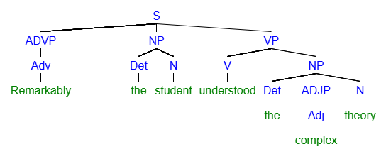
Question Twenty-Two: In the morning, she still felt quite anxious about the audition.
What sentence pattern is this sentence? Linking Verb
ROLE | Advl |  |  | Subj | Pred |  | Subject Complement
PHRASE | PP |  |  | NP | VP |  | ADJP
WORD | In | The | Morning | She | Still | Felt | Quite | Anxious | About | The | Audition
Part of Speech | Prep | Dete | N | Pro | Adv | N | Adv | Adj | Prep | Det | N

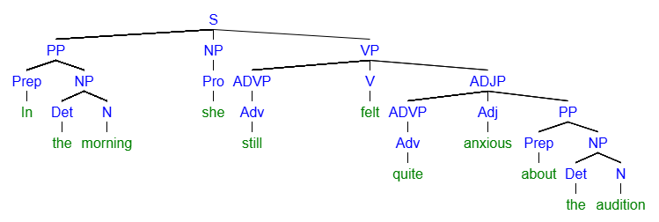
Question Twenty-Three: The director of the film offered the actor the lead role.
What sentence pattern is this sentence? Ditransitive with Direct Object and Indirect Object
ROLE | Subj |  |  |  |  | Pred | Indirect Object |  | Direct Object
PHRASE | NP |  |  |  |  | VP | NP |  | NP
WORD | The | Director | Of | The | Film | Offered | The | Actor | The | Lead | Role
Part of Speech | Det | N | Prep | Det | N | V | Det | N | Det | Adj | N

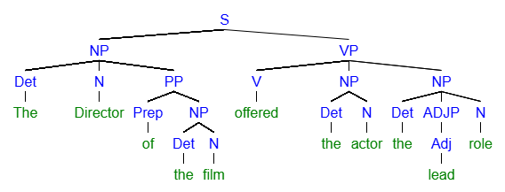

Section D: Coordination and Subordination -- Sentence Diagrams (6 pts each)
Instructions:
A. Label the sentence as Simple, Compound, or Complex
- Simple = One clause with conjoined phrases
- Compound = Two independent clauses with a coordinating conjunction
- Complex = One independent clause and one dependent clause with a subordinating conjunction
B. Complete a diagram in the style practiced in class
- If the sentence has multiple clauses, label them as Independent Clause - S(IC) and Dependent Clause - S(DC)
I have provided extra pages if you need them for corrections or practice. Please clearly indicate which is your final answer!

Question Twenty-Four: Because the traffic was heavy, the delivery arrived behind schedule.
Is this sentence Complex, Compound, or Simple? _______________________________
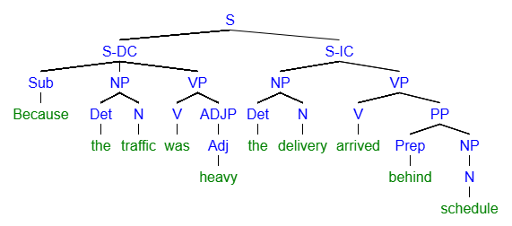

Question Twenty-Five: The researcher conducted the experiment carefully and recorded all observations.
Is this sentence Complex, Compound, or Simple? _______________________________
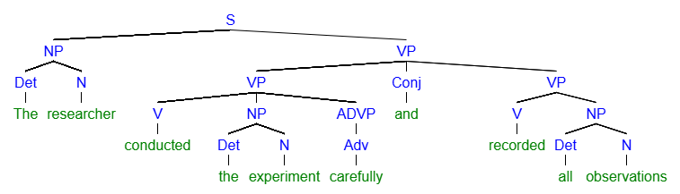

Question Twenty-Six: The musician practiced for hours, but, sadly, the audience considered his performance boring.
Is this sentence Complex, Compound, or Simple? _______________________________
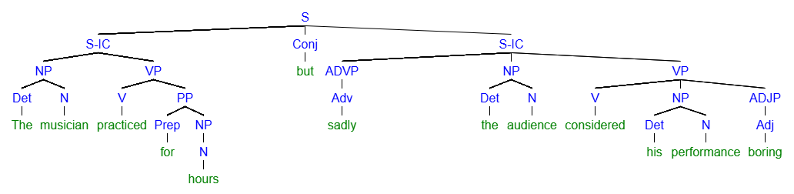

Question Twenty-Seven: Finally, the valley appeared to us as the sun rose over the mountains
Is this sentence Complex, Compound, or Simple? _______________________________
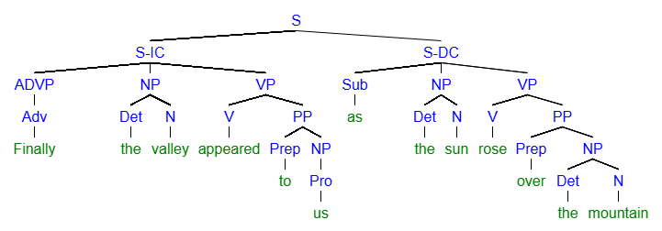

Section E: Sentence Creation -- Bonus
For this section, please write all the new sentences about a movie, book, or TV show you like. Feel free to reuse the same ideas and characters multiple times.
Name the movie, book, or TV show here: __________________________________________________________________________________
Question Twenty-Eight: (2 pts bonus)
Write a sentence containing a Noun Phrase Serving as an Object Complement.
We all considered Gumball a silly guy.

Question Twenty-Nine: (2 pts bonus)
Write a sentence containing a Prepositional Phrase serving as an Adverbial at the beginning of the sentence.
In the new show, Walker’s school bell is not what I imagined Percy to look like.

Question Thirty: (2 pts bonus)
Write a sentence with Three Conjoined Noun Phrases as the Object of One Preposition
I ate at McDonalds, Cheh Maggy, and Burger King.

Continued on next page…
Question Thirty-One: (2 pts bonus)
Write a sentence that is Complex AND Compound (contains two independent clauses and one dependent clause).
When Percy saw Annika, he fell in love, and he found a best friend too.

Question Thirty-Two: (2 pts bonus)
Write a sentence containing an Adjective Phrase as a Subject Complement.
Phillip is sorry for messing up the study guide.

